Mass Spectrometry Facility

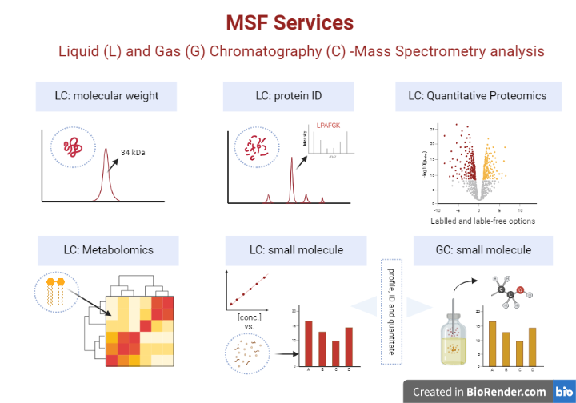
The Mass Spectrometry Facility provides mass spectrometry analysis to researchers and assists in the development and analysis of mass spectrometry experiments. The following services are available in the Mass Spectrometry Facility (MSF):
Highlighted Services and Example of Fees

Service | Internal Fee | Typical Project Comparing Two Sample Groups*
Protein Identification | 50/sample
Label-free Protein Quantitation |  | Whole protein extracts,4 reps each
Data acquisition Thermo Exploris | 100/1hr, 150/2hr | $1200
Peaks Online Access and training | $1200/year | $1200
 | Total | $2400 for first project $1200 for subsequent
Untargeted Metabolomics |  | Extracts, 4 reps each plus QC
Data Acquisition | 50/injection | $500
Data Analysis training | $100/person | $600 total
 | Total | $1100
*Contact the Facility for specific pricing.

Additional services include small molecule characterization and quantitation (GC/LC-MS) as well as protein molecular weight determination. Project design, sample preparation recommendations and guidelines are available through the website or by contacting the Facility.
Contact: Dr. Dyanne Brewer dbrewer@uoguelph.ca Website: https://www.uoguelph.ca/aac/MSF

