http://nmr.uoguelph.ca
(519) 824-4120 x58914

Our NMR Centre is home to six NMR spectrometers and provides service to all academic communities and industry at competitive prices and with rapid throughput. Our 600 MHz NMR spectrometer with 60-slot autosampler and high-sensitivity cryoprobe is ideal for metabolomic studies, while our high-field 800 MHz spectrometer provides the extreme resolution needed for the most challenging samples.

Here are a few examples of campus research supported by the NMR Centre:
- Metabolomic profiling of biofluid samples¹
- Structural elucidation of small molecules (e.g., identifying a molecule from a purified extract of plant material)^{2, 3}
- Probing interactions between large and small molecules (e.g., protein/drug interactions)⁴

The above is only a small subset of what we can do. If you have a specific NMR experiment in mind, we likely have the equipment and expertise to carry it out.

Metabolite Profiling by NMR

Using well-established techniques, we can identify and quantify small molecule metabolites in extracted biofluids (e.g., urine, blood, fecal water/robogut systems) at concentrations as low as tens of µM. Our Chenomx software database contains over 330 small molecules, such as short-chain fatty acids, amino acids, mono-saccharides, TCA cycle compounds, and much more.

Here’s the process:
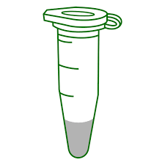
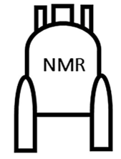
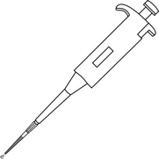
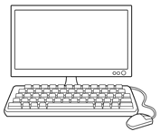

We (or you) identify and quantify metabolites on our Chenomx PC, then export concentrations to Excel
You add a low-cost internal standard & transfer to an NMR tube (we can provide both)
We (or you) collect the NMR data on our spectrometers
You prepare a filtered metabolite extract in 540 µL water

Service Options & Rates:

We offer both full-service and self-service options, so you can select what works best for your project and budget. For new projects, we recommend starting with a full-service pilot on 1-2 samples: from your filtered metabolite extracts we will collect the NMR data and provide an Excel file with concentrations of all the metabolites we can identify (typ. 30-50). A pilot costs around $100-$150, while larger projects usually have far lower per-sample costs.

Contact Sameer at s.wahid@uoguelph.ca to discuss your project and how we can help.

